In the XYZ airline, there is a special queue designed for entering the plane. Passengers are regularly queued by their time of arrival. However, there are some exceptions: VIPs and the elderlies. Here is how the queuing system works:

Priority 1: VIPs. If there are more than one VIPs, VIPs are ordered by their arrival time to the queue.

Priority 2: Elderlies. Elderlies are regular passenger aged more than 55. If there are more than one elderlies, elderlies are ordered by their arrival time to the queue.

Priority 3: Regular Passengers. If there are more than one passengers, they are ordered by their arrival time to the queue.

Create a program with the following description:

1. Main menu displaying current passengers in queue, including: **name, age, and status (Regular/Elderly/VIP)**. Show also the **maximum and minimum age** of the passengers and the **total passengers count** in the queue.
2. Menu 1 for entering a new passenger to the queue. Accept the following data: **name, age, status (VIP or regular)**. **Note** there is no elderly status inputted to the program. Elderly status is determined by age.
3. Menu 2 for dequeuing a passenger. Display the dequeued passenger **name**.
4. Menu 3 for exiting the program.

**Tampilan Awal :**

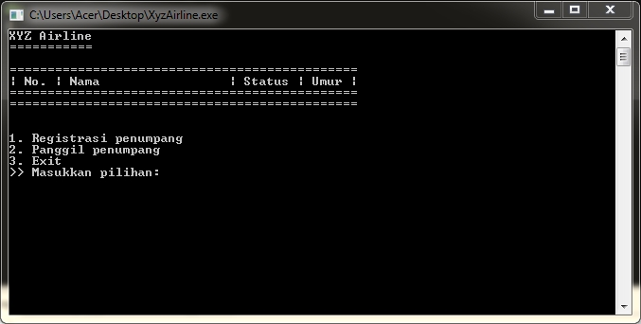

**JIka Memilih Menu 1, Maka Tampilannya :**

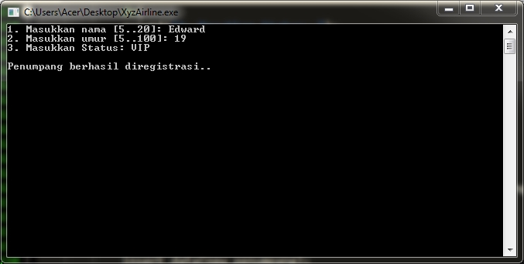

**Tampilan ketika banyak data sudah diinput :**

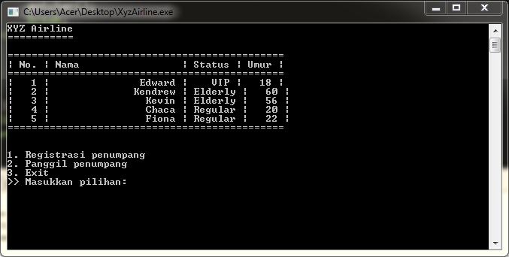

**Ketika Memilih Menu 2, maka Hapus data paling awal , menjadi :**

